RDS Assignment 1

Requirement: Launch instance and connect with database, deploy war on tomcat server using declarative pipeline.

Lunch E2 instance

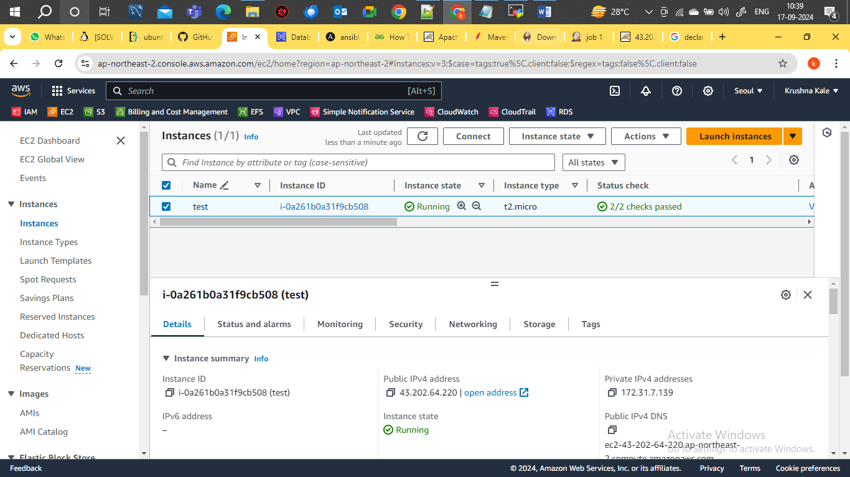

Create db instance

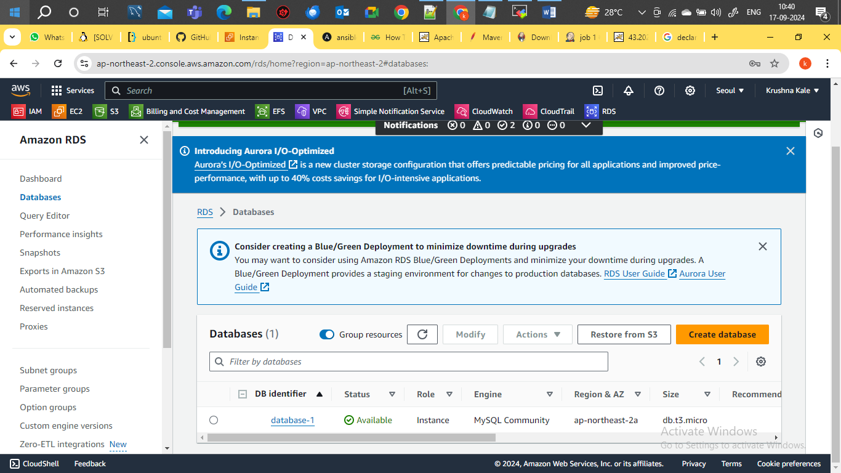

Created Pipeline job

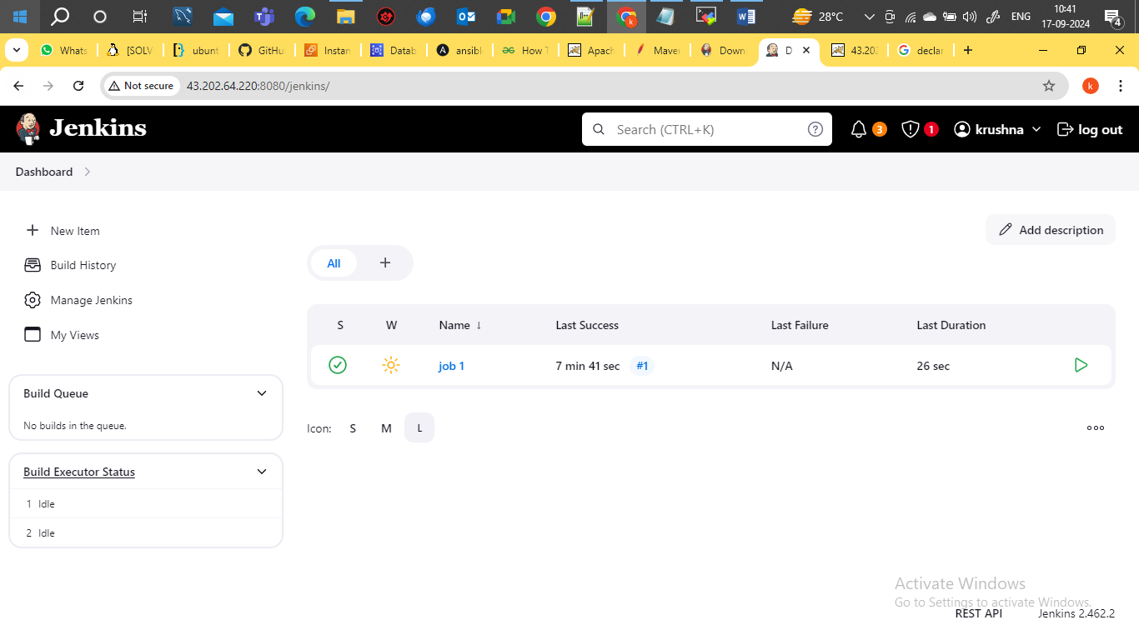

Pipeline Script

pipeline{

agent {

label{

label "built-in"

customWorkspace "/mnt"

}

}

stages{

stage("clone repo"){

steps{

sh "rm -rf demoproject\*"

sh "git clone https://github.com/kkale0901/demoproject.git"

}

}

stage("application and database integration"){

steps{

sh "sed -i 's/localhost/database-1.cxiaygkceoe1.ap-northeast-2.rds.amazonaws.com/g' /mnt/demoproject/src/main/webapp/userRegistration.jsp"

sh """sed -i 's/"root", "root"/"admin", "krushnakale"/g' /mnt/demoproject/src/main/webapp/userRegistration.jsp"""

}

}

stage("build application"){

agent {

label{

label "built-in"

customWorkspace "/mnt/demoproject"

}

}

steps{

sh "mvn clean install"

}

}

stage("dploy war to tomcat"){

steps{

sh "rm -rf /mnt/servers/apache-tomcat-9.0.94/webapps/LoginWebApp\*"

sh "cp /mnt/demoproject/target/LoginWebApp.war /mnt/servers/apache-tomcat-9.0.94/webapps"

}

}

}

}

Job executed successfully

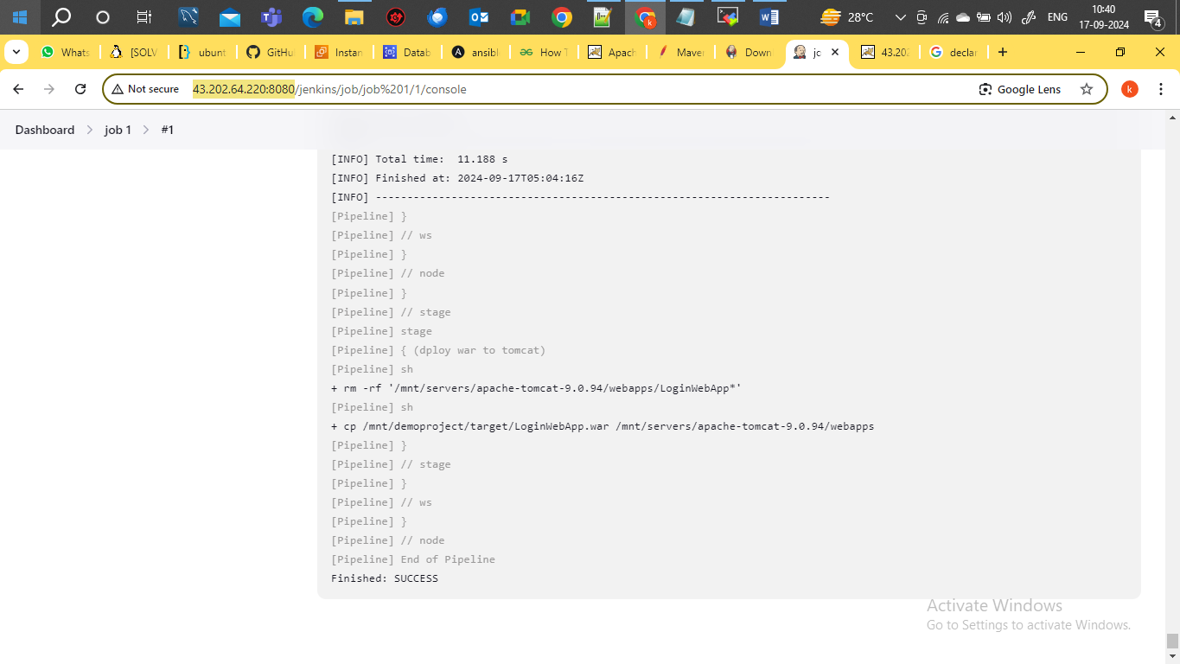

Application Deployed

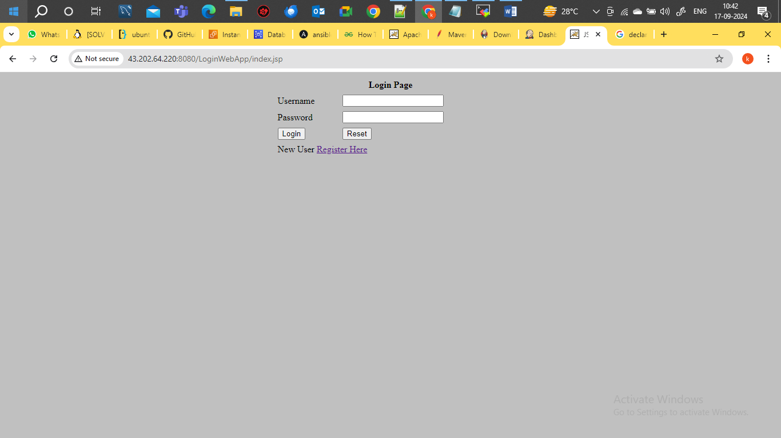

Data stored in backend in database

